June 21st, 1991
Lam Dong, Viet Nam
+84 965 739786
ledaiduong686@gmail.com

https://www.linkedin.com/in/le-dai-duong-3704b9169/
ACHIEVEMENT
- Participate managed a project 30MW solar plant successfully operation at the FIT 1 tariff.
- Managed operations of 02 solar power plants (39MWp and 50MWp), achieving annual generation targets of over 55 GWh and 80 GWh without significant incidents.
- Stable advancement at work.

SUMMARY OF QUALIFICATION
- Technical expertise: 11 years in energy systems operation and maintenance.
- People Management: Leading teams to meet performance goals.
- Problem-solving: Strong decision-making, logical thinking, creativity, and ability to work under pressure.
- Relationship Management: Build positive connections with local authorities and power sector agencies.
- Safety Awareness: Knowledgeable in HSE compliance and industry standards.
SKILLS
- O&M of automatic electricity, solar systems, and substations.
- Fault identification, diagnosis, and troubleshooting.
- Knowledge of Vietnam's electricity regulations.
- Quick learner with excellent communication skills.
- Proficient in Microsoft Office, MS Project, Power BI, basic Python, and AutoCAD (2D-3D).
- Driver's license.
LE DAI DUONG
For over 11 years of experience in transmission energy, operation of high voltage substations, project management, and renewable energy.


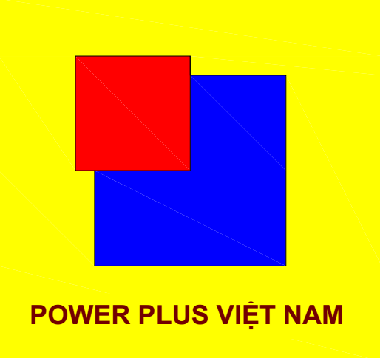

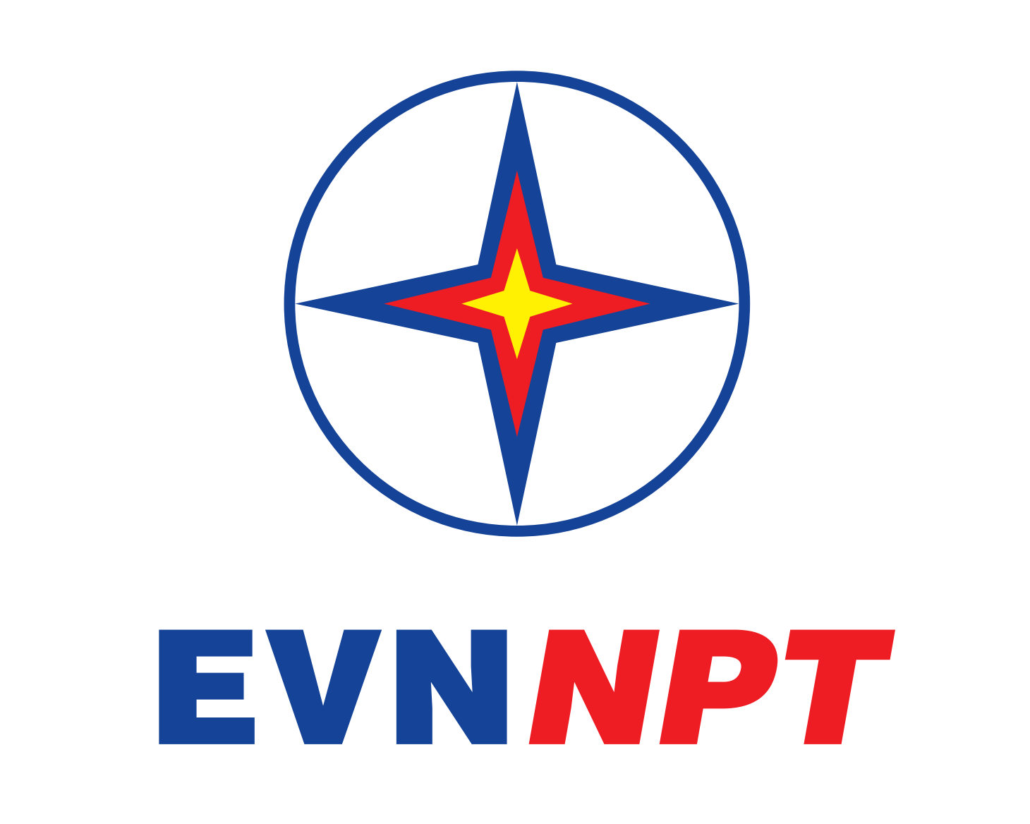

EMPLOYMENT HISTORY
Plant manager (12/2024 – Now)
Vinh hao 6 (50MWp Solar Plant) – Leader energy group
- Manage all the O&M activities.
- Monitor the electric generating performance daily
- Resolve the technical incidents.
- Set up the maintenance plan & corresponding budget cost for projects and works
- Manage compliance: HSE, reports, permits & licenses.
Plant manager & Head of substation (6/2019 – 10/2024)
Tuy Phong 39MWp Solar Plant – Power Plus Viet Nam
- Equipment monitoring ensures efficient electricity generation.
- Supervising staff, managing budgets and schedules, and ensuring safety compliance & maintaining stakeholder relationships.
Project Manager (10/2018 – 6/2019)
Tuy Phong 39MWp Solar Plant Project– Power Plus Viet Nam
- Develop project plans, schedules, budgets, and performance goals.
- Oversee the design and construction of renewable energy facilities.
- Monitor project progress and adjust as needed.
- Coordinate and supervise project teams for timely completion.
Technical staff (7/2017 – 10/2018)
Technical Deparment - Power Transmision No.3
- Managed operation & handled substations incident resolution.
- Developed Standard Operation and Maintenance Process.
Operation & Maintenance Engineer (9/2014 – 7/2017)
Vinh Tan 500kV, Ham Tan 220kV, Thap Cham 220kV - Power Transmision No.3
- Supervision construction and installation of substations
- O&M substations and resolving incidents
when they happen

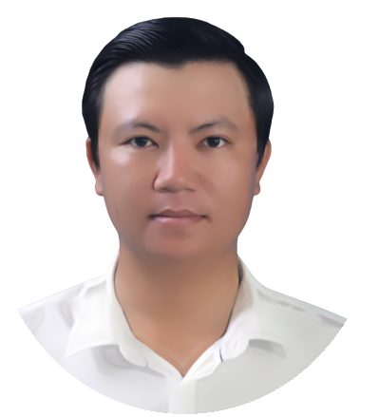

LANGUAGE
Working proficiency in English

Speaking: Moderate
Listen: Fair
Writing: Fair







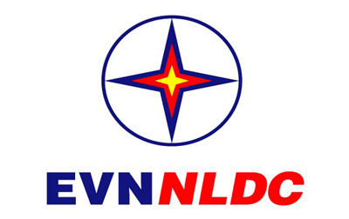
EDUCATION & CERTIFICATE
University of Technical Education HoChiMinh city Bachelor of Electric Automation
EVNNLDC (National Load Dispatch Centre):
Certificate of Operation: Power Factory & Substation
PACE (Pace school of Leadership & Management)
Action Plan & Performance Report.
HCM City Electric Power College
Certificate of connection and installation techniques of medium voltage cable
FULBRIGHT UNIVERSITY
Capacity building in natural resource management

Reading: Good

PERSONAL INFORMATION

